**DAILY ONLINE ACTIVITIES SUMMARY**

|  |  |  |  |  |  |  |  |  |
| --- | --- | --- | --- | --- | --- | --- | --- | --- |
| **Date:** | **09/06/2020** | | | | | **Name:** | **Lavanya D M** | |
| **Sem & Sec** | **4th & ‘A’** | | | | | **USN:** | **4al18cs041** | |
| **Online Test Summary** | | | | | | | | |
| **Subject** | | **nil** | | | | | | |
| **Max. Marks** | | **nil** | | **Score** | | | **nil** | |
| **Certification Course Summary** | | | | | | | | |
| **Course** | **VMware lab** | | | | | | | |
| **Certificate Provider** | | | **Bitdegree** | | **Duration** | | | **1 week** |
| **Coding Challenges** | | | | | | | | |
| **Problem Statement:** 1)Write a C Program to rotate the matrix by K times Program in C  **2)** Write a java program to count all the triplets such that sum of two elements equals the third element  **3)** Write a Java Program to find total number of subarrays which start and end with the same element | | | | | | | | |
| **Status: complied** | | | | | | | | |
| **Uploaded the report in Github** | | | | | **yes** | | | |
| **If yes Repository name** | | | | | <https://github.com/lavanyamurthi/lockdown-coding/tree/master> | | | |
| **Uploaded the report in slack** | | | | | **yes** | | | |

Online Test Details: (Attach the snapshot and briefly write the report for the same)

Certification Course Details: (Attach the snapshot and briefly write the report for the same)

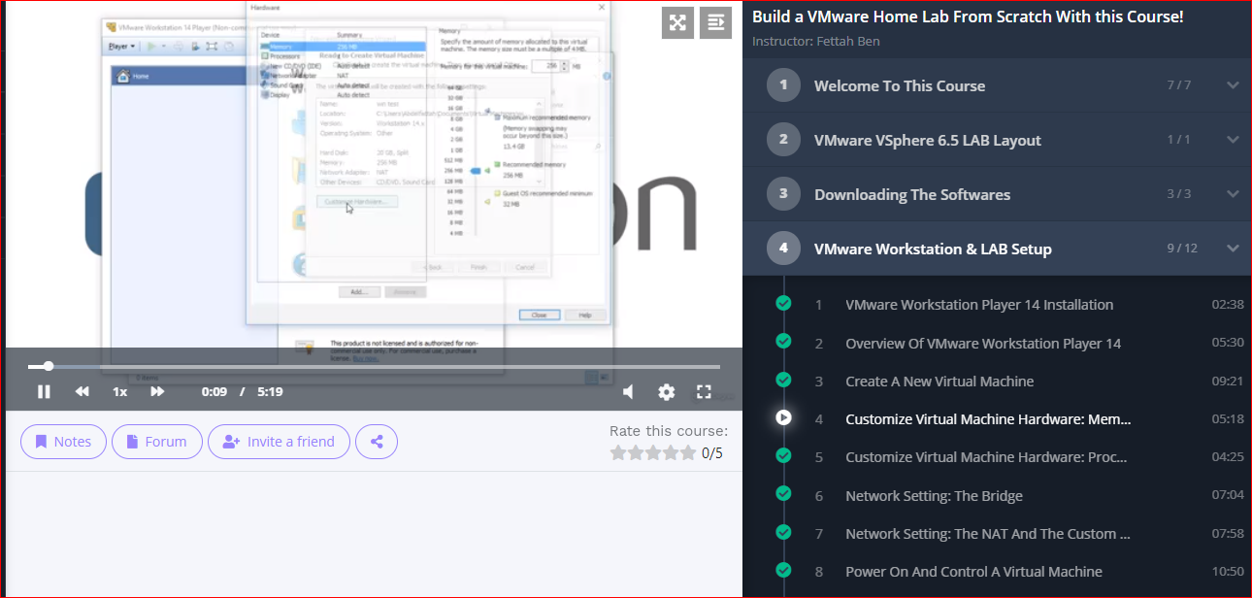

Coding Challenges Details: (Attach the snapshot and briefly write the report for the same)

**Problem 1:** Write a C Program to rotate the matrix by K times Program in C

Rotate the matrix by K times means rotating the given NN matrix to the specified (K) number of times. For example, consider the 33 matrix, which has to be rotated once,  
Enter the Size of the Matrix: 3, 3  
Enter the Elements of the Matrix: 10, 20, 39, 40, 50, 60, 70, 80, 90  
Enter the value of K (Number of Rotations): 1  
Matrix before Rotation:  
10 20 30  
40 50 60  
70 80 90  
Matrix after Rotation:  
20 30 10  
50 60 40  
80 90 70

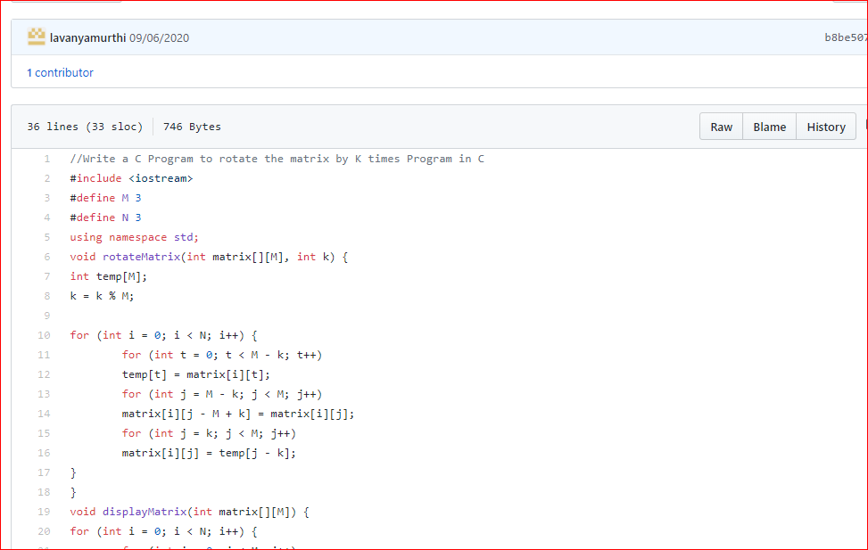

Problem 2: Write a java program to count all the triplets such that sum of two elements equals the third element

Given an array of distinct integers. The task is to count all the triplets such that sum of two elements equals the third element.

Input:  
The first line of input contains an integer T denoting the number of test cases. Then T test cases follow. Each test case consists of two lines. First line of each test case contains an Integer N denoting size of array and the second line contains N space separated elements.

Output:  
For each test case, print the count of all triplets, in new line. If no such triplets can form, print "-1".

Constraints:  
1 <= T <= 100  
3 <= N <= 105  
1 <= A[i] <= 106

**Example:**  
Input:  
4  
1 5 3 2

Output:  
2

Explanation:  
There are 2 triplets: 1 + 2 = 3 and 3 +2 = 5

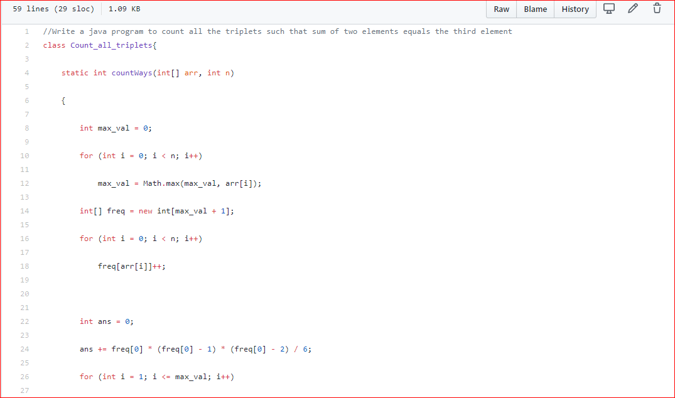

Problem 3: Write a Java Program to find total number of subarrays which start and end with the same element

Given an array A of size N where the array elements contain values from 1 to N with duplicates, the task is to find total number of subarrays which start and end with the same element.  
**Examples:**

Input: A[] = {1, 2, 1, 5, 2}  
Output: 7  
Explanation:  
Total 7 sub-array of the given array are {1}, {2}, {1}, {5}, {2}, {1, 2, 1} and {2, 1, 5, 2} are start and end with same element.

